# Creating “Prep File” from MassHunter Output

* Prepare MassHunter output xlsx for conversion to “prep file” xlsx (MATLAB input):
  + Make sure inaccurate AUCs are deleted from MassHunter output xlsx
  + MassHunter output xlsx must end with “**FAMES**” or “**CHOL**”
  + Add “Code” column before “Name” column:
    - 1 = to model
    - 0 = use to determine q
    - 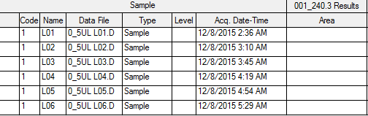-1 = ignore
* Create “prep file” xlsx (MATLAB input) from MassHunter output xlsx.
  + Open R: 
  + Open “GCMS pipeline – Shortcut” folder on desktop
  + Drag  onto R window
  + Select raw AUC data file(s) for anaylasis.
  + Converted files will be in the same folder.
  + Check to make sure “prep file” is correct.
  + Close R, don’t save.

Copy/paste to consolidate LC and VLC prep sheets

* MATLAB modeling:
  + Copy this  file to your folder for analysis, and rename it.
  + Double-click open this .m file e.g. (you will have to wait for 2 windows in MATLAB to pop-up, 1st is workspace, 2nd is your .m file) 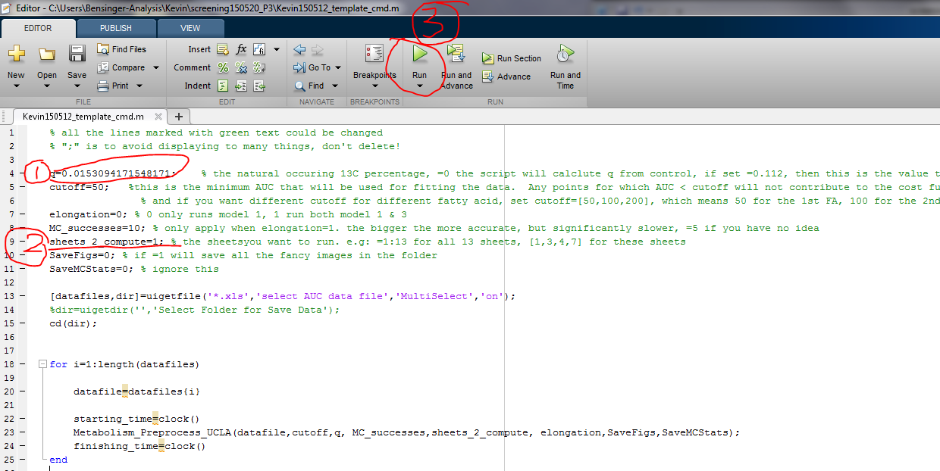

The window for .m script

* + As shown in the figure above**, change q and lambda value**(0 means let MATLAB calculate from your non-labeled sample, or you can force it to use designated value. If there is no non-label nor designated value, model will use default q=0.011, lambda=0.023), **change the sheets** you want to process in “**prep_150524Plate020P3D4BFAMES.xlsx**” :
    - sheets_2_compute=1 🡪 only compute 1st sheet
    - sheets_2_compute=1:5 🡪 compute sheet #1~5
    - sheets_2_compute=[1,3,4,6] 🡪 compute sheet # 1,3,4,6
  + hit “Run” 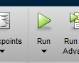
  + go to the other window in MATLAB: should be reading and computing data now….
  + “Ctrl+C” to terminate the process

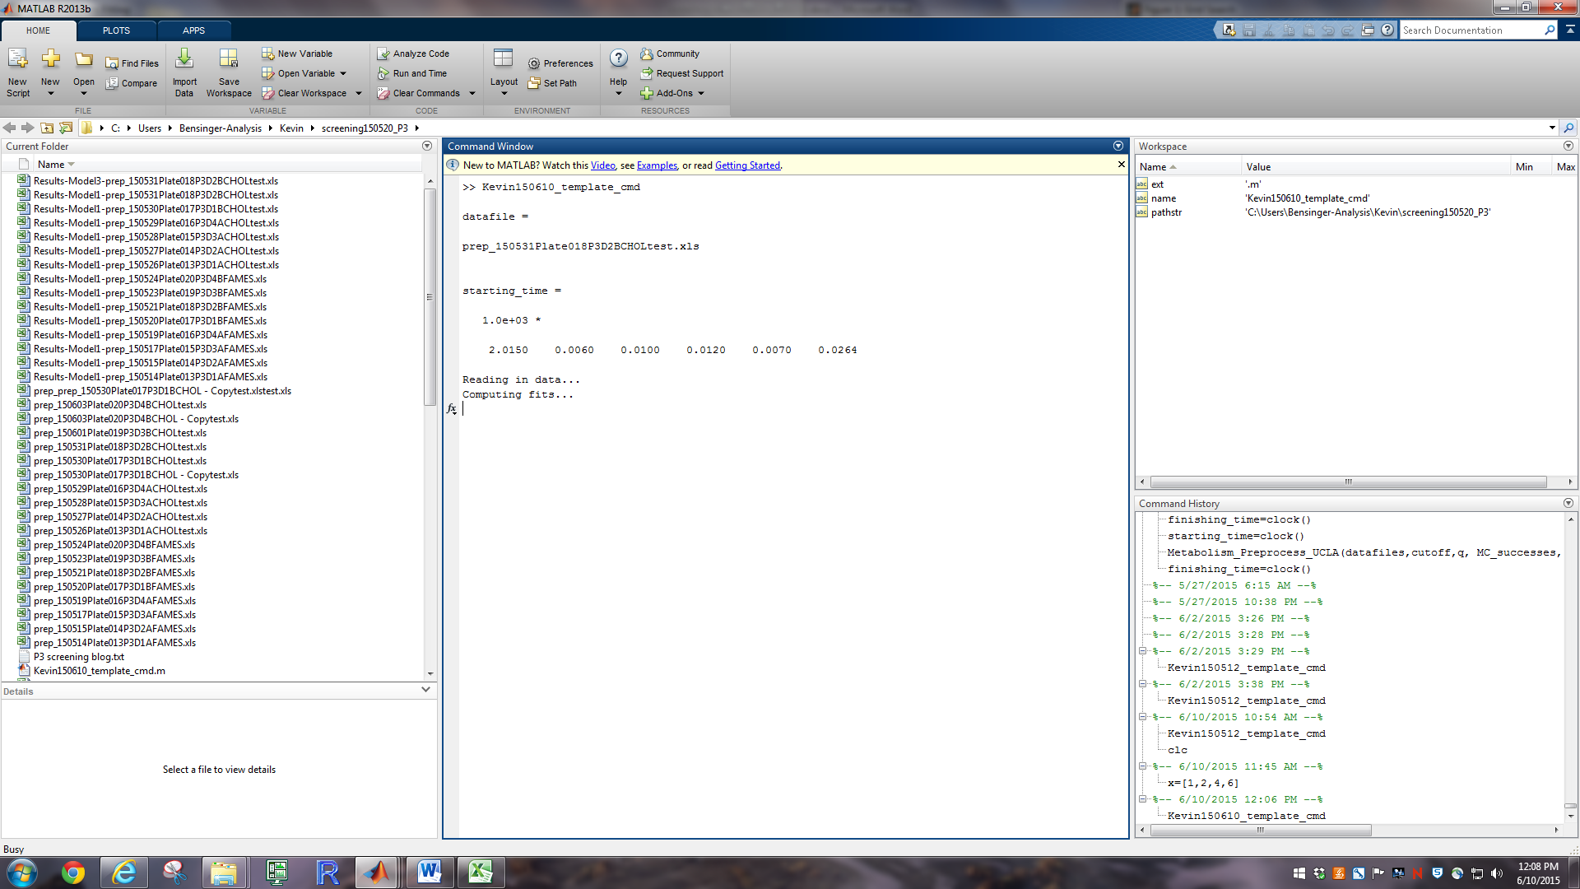

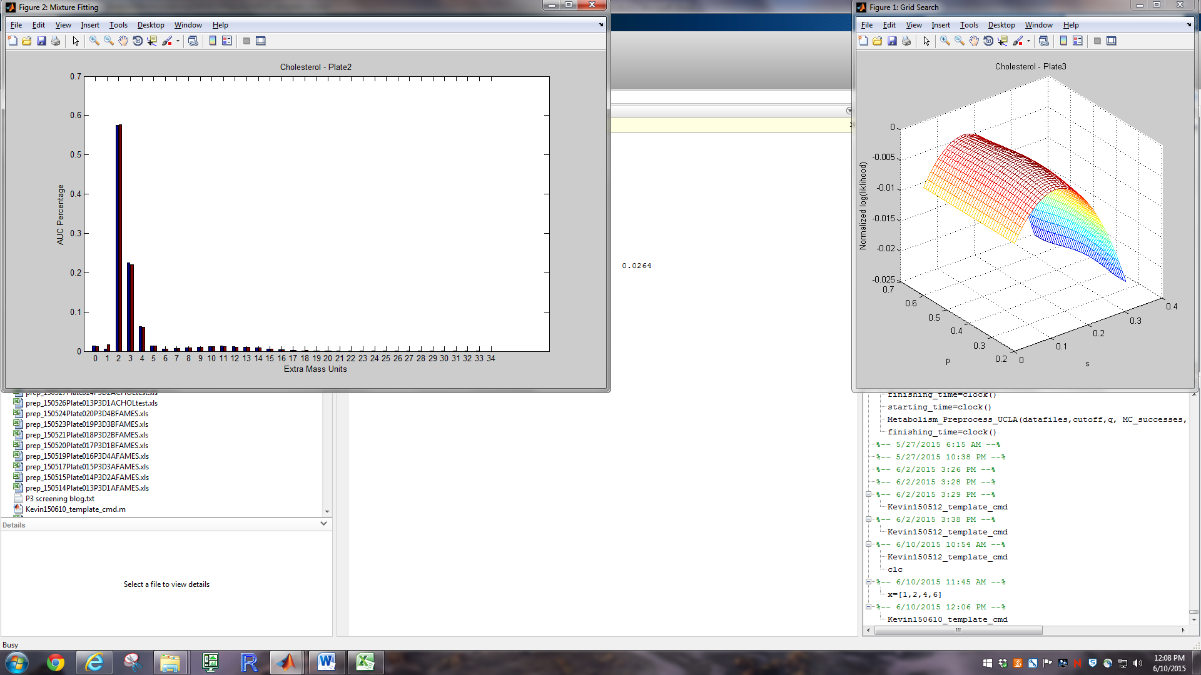

Time:

Model 1: 140-160-161-180-181 for 88 samples take 1 hour, chol for 88 samples take 40min

Model 3: 160-180-181 for 88 samples take 12 hours